Histidine pK_{a} Determination

The imidazole side chain of histidine exhibits a relatively neutral pK_{a}. Consequently, Nature employs the versatile histidine residue for a variety of functions in proteins, including metal ion coordination in metalloproteins and enzyme catalysis. The side chain also exists in three forms in solution, two neutral forms (the N^{δ1}H and N^{ε2}H tautomers) plus the positively charged imidazolium ion, in which both N^{δ1} and N^{ε2} are protonated (see Figure 1).

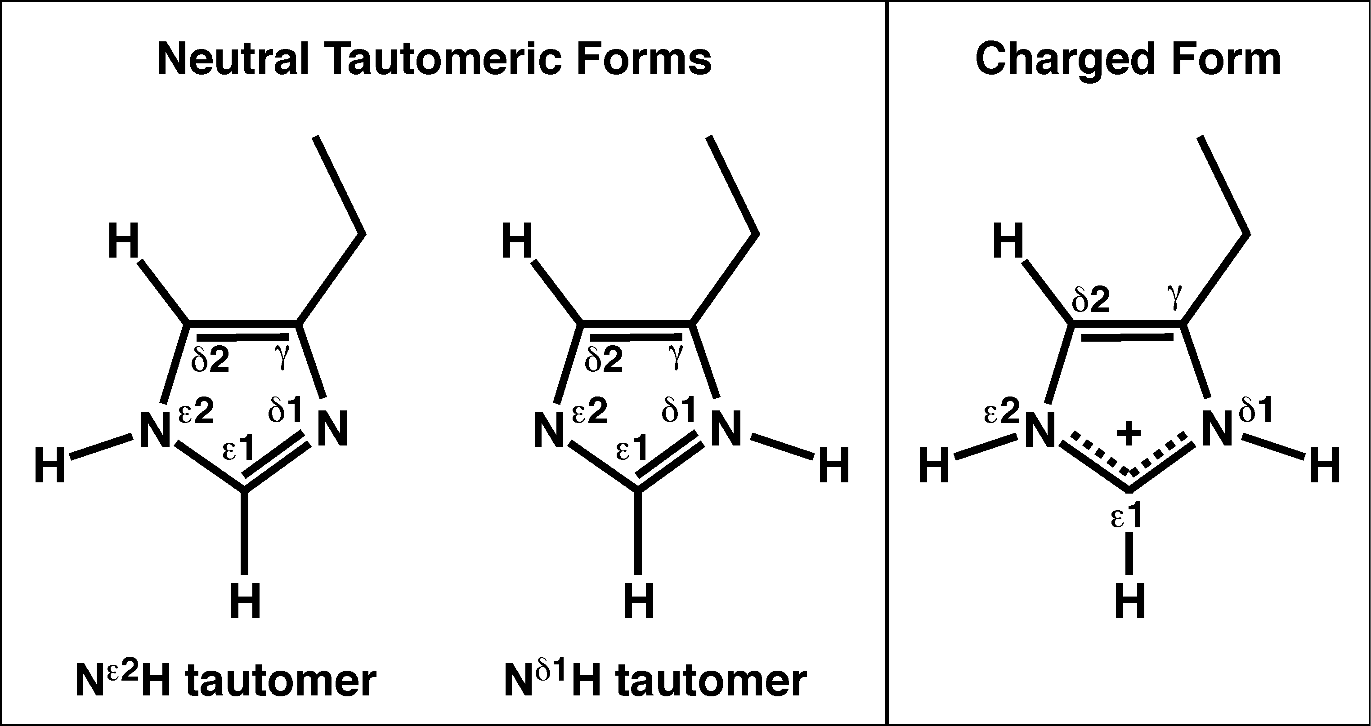

Figure 1: Neutral tautomeric and charged forms of histidine.

Histidine pK_{a} values can be easily determined by monitoring the pH dependence of the chemical shift of H^{ε1}, located between the two titrateable nitrogens in the imidazole ring. This is most conveniently done by obtaining a 2D aromatic ¹H-¹³C HSQC NMR spectra on a ¹³C,¹⁵N double-labeled protein sample. Experiments are performed at pH intervals of 0.2 to 0.3, over a pH range of ca. 4 to 9. Using a double-labeled protein sample and a 5-mm cryoprobe, one can easily acquire 2D aromatic ¹H-¹³C HSQC NMR spectra in ca. 30 min (1024 x 100 points; 16 scans per increment). The H^{ε1} chemical shift vs. pH data for each histidine are then fit to a modified Henderson-Hasselbalch equation (see below). In practice, we found that the 1D ¹H-detected version of the experiment acquired on a 5%-¹³C,100%-¹⁵N protein sample is too insensitive to perform in a reasonable period of time necessary for a full pH titration. Moreover, the 2D HSQC removes any degeneracy among H^{ε1} signals due to the hexa-His tag and overlap from other aromatic resonances (i.e., Trp aromatic protons).

In our own work we have used this approach to determine the pK_{a} values of active site histidines in two cysteine peptidases, the NlpC/P60 domain of E. coli Spr (NESG ID ER541) (see Figure 2),¹ and the CHAP domain from S. saprophyticus (NESG ID SyR11).² In both cases, the pK_{a} values of the active site histidines were reduced (pK_{a} = 5.5), confirming our view that a neutral form of the histidines was stabilized by a hydrogen-bonded catalytic network within the active sites of each enzyme.

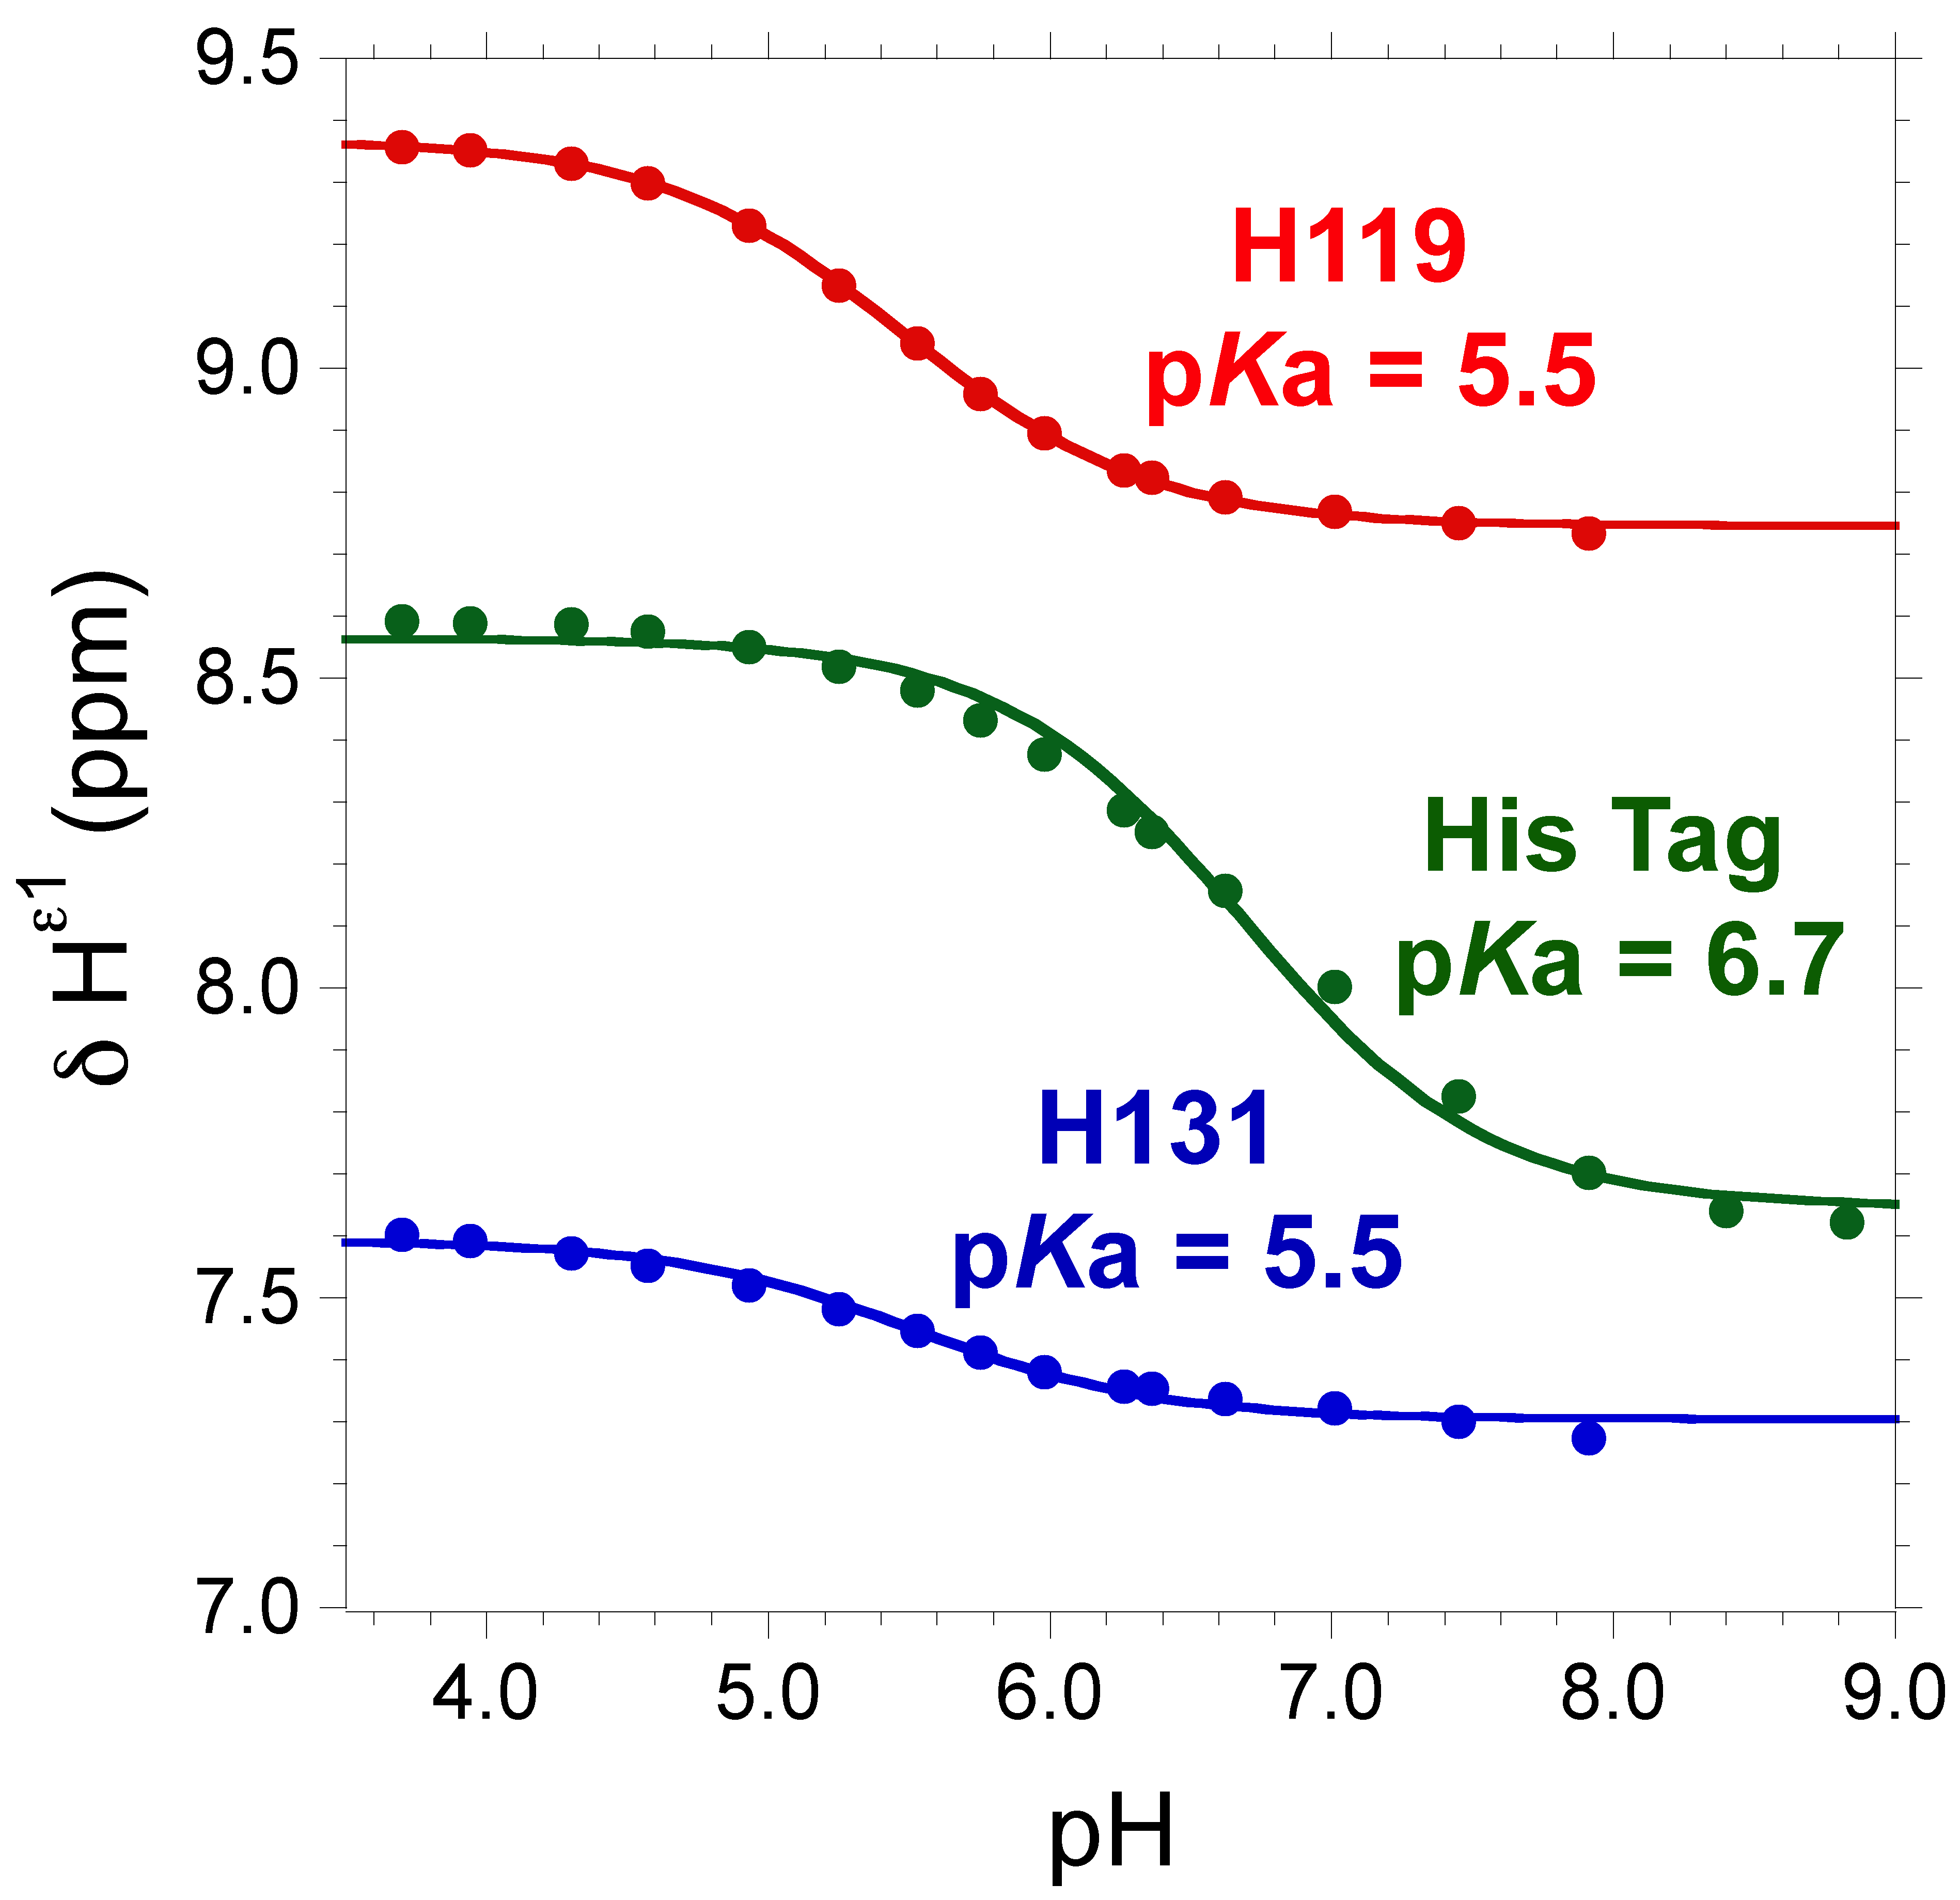

Figure 2: Plots of histidine H^{ε1} chemical shift as a function of pH for U-¹³C,¹⁵N E. coli Spr[37-162] at 298 K, obtained by 2D ¹H-¹³C HSQC NMR. Red, H119; blue, H131; green, C-terminal hexa-His tag (control); pK_{a} values for each are indicated on the plot.
By way of an example, here is the protocol used in the ER541 pK_{a} titration:
Histidine pK_{a} values for both active site histidines (H119 and H131) were determined by monitoring H^{ε1} chemical shifts as a function of pH for U-¹³C,¹⁵N E. coli Spr[37-162] using 2D ¹H-¹³C HSQC NMR spectroscopy (Bruker 800 MHz spectrometer; 298 K). As a control, we also monitored the pH dependence of one cross-peak from the C-terminal His tag. The pH was adjusted with μL amounts of 0.1 N HCl or 0.1 N NaOH. The sample becomes turbid at pH values above 7, and the His tag peaks coalesce at the two pH extremes. Histidine pK_{a} values were obtained by non-linear least squares curve fitting (R > 0.99) to a modified Henderson-Hasselbalch equation using KaleidaGraph 4.0 (Synergy Software):³
$d_{\text{obs}}=\frac{d_{\text{AH}}+d_{A}{\text{10}}^{(\text{pH}−\text{pKa})}}{1+{\text{10}}^{(\text{pH}−\text{pKa})}}$ (1)
where δ_{obs} is the observed chemical shift at each pH value, and δ_{AH} and δ_{A} are the chemical shifts of the protonated (charged) and deprotonated (neutral) histidine forms, respectively.

REFERENCES

1. Aramini, J. M., Rossi, P., Huang, Y. J., Zhao, L., Jiang, M., Maglaqui, M., Xiao, R., Locke, J., Nair, R., Rost, B., Acton, T. B., Inouye, M., and Montelione, G. T. (2008) Solution NMR structure of the NlpC/P60 domain of lipoprotein Spr from Escherichia coli: Structural evidence for a novel cysteine peptidase catalytic triad. Biochemistry (Rapid Report), in press.

2. Rossi, P., Aramini, J. M., Xiao, R., Chen, C. X., Nwosu, C., Owens, L. A., Maglaqui, M., Nair, R., Fischer, M., Acton, T. B., Honig, B., Rost, B., and Montelione, G. T. (2008) Proteolytic Cys-His-Glu-Asn relay in the secreted CHAP domain enzyme from the human pathogen Staphylococcus saprophyticus. Proteins, in press.

3. Wolff, N., Deniau, C., Létoffé, S., Simenel, C., Kumar, V., Stojiljkovic, I., Wandersman, C., Delepierre, M., and Lecroisey, A. (2003) Histidine pK_{a} shifts and changes of tautomeric states induced by the binding of gallium-protoporphyrin IX in the hemophore HasA_{SM}. Protein Sci. 11, 757-765.

